Present Date  John  Grzegorz Śledź  Daniel Zaucha  Ehsan Golesorkhi | Date  07-07-2016
Ehsan Golesorkhi | 14-07-2016

Meeting objective
To clarify the requirements that we get earlier, the requirements were below:

1 | Board
2 | Standard ship-sets
3 | Standard rule-sets
4 | GUI
5 | Fast Game
6 | HUMAN-HUMAN Player Or HUMAN-AI PLAYER

Action review

1. Board
a.Consist of 10x10 fields and it can be changed in the future.

2. Standard ship-sets.
a. In the future standard ships can be changed ( features: color, name ), so team is ready for changes. For now ships are set like in normal, ordinary game battle ship.

3. Standard rule-sets
a.We didn’t talk about the rules exactly so just use the standard ones.

4. GUI
a.The customer doesn’t have any proposition until now for the GUI. It is not clear if the application is a web application or desktop application.

5. Fast Game
a.The flow of the game must be fast.

6. This game has 2 players and it could be HUMAN-HUMAN or HUMAN-AI.

Use Case diagram :

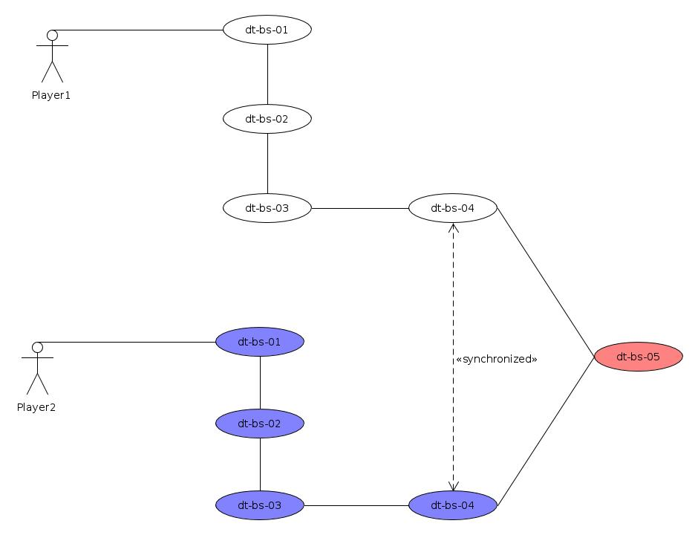

Name | Sign up the Player
ID | Dt-bs-01
Description | Player is able to register himself by name and surname. The data are stored for one time game.  At the same time many players could register himself.
Triggers | The user will write his Name and Surname and registers himself.
Preconditions | There is no stage before this one.
Exception | The user will be informed that something goes wrong

Name | Placing the ships
ID | dt-bs-02
Description | The user gets a set of ships and he is now able to placing the ships in valid places.
Triggers | The player placing the ships and prepare himself for the game.
Preconditions | In this step player already registred himself.
Exception | The user will be informed that something goes wrong

Name | Waiting
ID | dt-bs-03
Description | The player is waiting for another player to prepare himself.
Triggers | Playes does nothing just wait.
Preconditions | Player already set the place of the ships in his board.
Exception | The user will be informed that something goes wrong

Name | Playing
ID | dt-bs-04
Description | The players will play with each other. In a synchronized way. It means that player1 damage a ship wait to player2 damage the field and so on until someone will win.
Triggers | Player can choose fields that he wants.
Preconditions | 2 players are already set the ships in theyr maps, and they are ready to play.
Exception | The user will be informed that something goes wrong. If the Exception will be serius, the player will not able to play but they will be informed about that.

Name | Result
ID | dt-bs-05
Description | The result will be shown
Triggers | Players in this step jus seeing the result.
Preconditions | 2 players are already set the ships in theyr maps, and they are ready to play.
Exception | The user will be informed that something goes wrong. If the Exception will be serius, the player will not able to play but they will be informed about that.

